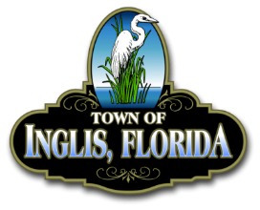

INGLIS RECREATION COMMITTEE
Meeting Agenda
September 15, 2025 @ 6:00 PM

MISSION STATEMENT: The Inglis Recreation Committee mission is to promote recreation and education of the children, seniors, and families in our community.

Pledge
Roll Call
AGENDA
- Future Event Planning

Adjourn

