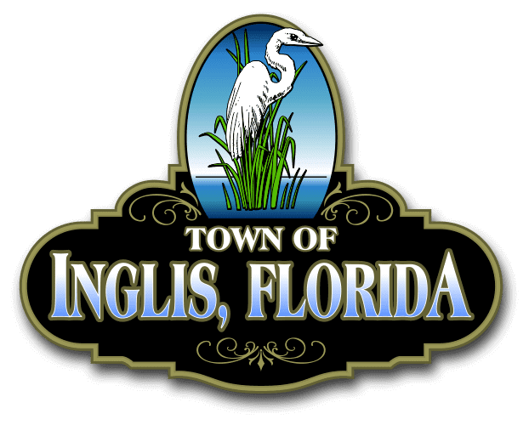
TOWN OF INGLIS
RECREATION COMMITTEE AGENDA MINUTES
December 15, 2025, 6:00 PM
TOWN HALL COMMISSION ROOM

Roll call:
Commissioner/ Daryl Lynaugh(present)
Chair/ Chris McGann (present)
Co-Chair/ Anthony Fattorusso (present)
Sec & treasurer/ Zully Velazquez (present)

REGULAR AGENDA
Old business:
Tree lighting and movie in the park update and expenses
About 40 people attended, with lots of compliments and were under approved budget. Movie in the park was cancelled due to weather. About 65 people attended the event when moved to community building. We were under approved budget
Thanksgiving lunch
Meal was provided at no cost to IRC
Christmas decorations update
New decorations were donated for Commission room, Community center, Fire Dept. And code enforcement/ Animal control
Popcorn machine and supplies purchased.
It was not a budgeted item, and was voted 3-0 for reimbursement approval
Santa Paws event update and expenses
Good turn out $148 donated to Animal Control
UTV purchased
It was a budgeted item, paperwork complete
Breakfast with Santa will be held on December 13th from 8:00 am until 11:00am with a $700.00 budget. Will include bacon, pancakes, scrambled eggs, milk, coffee, orange juice. Santa will be available during this time for pictures. Santa will be available from 9:00 to 11:00 Desiree will provide guidance for this event and will reach out to bank for volunteers.
Good turnout estimated 260 attendees, it was under approved budget.
Update: Christmas parade pre-party will be from 3:00pm to 5:00 pm with a $300.00 budget. will provide tents, tables, coffee, water, and Christmas cookies. Immediately to break down and any volunteers who wish will go assist Yankee Town
Was well attended, came in under approved budget. Chris volunteered at Yankee Town event per request.
Grand Marshall’s
(2) two banners purchased and were not a budgeted item. Vote was 2-0 (chris abstained) to approve reimburse. Zully will follow up.
Fire Dept. decorations.
Completed.
Float
Budgeted item, Zully will turn in receipts.

New business:
IRC shed security.
Chris will change combinations on locks
Discuss January closing.
Chris made a motion not to have any meetings or events in January to give volunteers a break. Vote was 3-0 to approve, Daryll will make commission aware.
Update on Budget for year end
Approved payment on current receipts votes 3-0 to approve.
Discuss control of Kitchen during events.
Only approved volunteers to be in kitchen area during events, better vigilance on keeping floor clean.

Continue discussion on future events:
Senior social night will be held December 20th from 5:00 pm to 8:00pm. Discuss menu, budget, volunteers, music bingo, and DJ.
Menu determined, entertainment arranged and budget set at $1500. Vote was 3-0 to approve.
Update employee Christmas party
No I.R.C. involvement needed
Discuss Junior night for middle school and partner with the school
Chris had meeting with principal and SRO and will be a partnered event on school property. School will furnish chaperons and will have a follow up meeting in January.
Discuss IRC budget fund raising event for March date.
Chris has spoken with Mr. Pratt about a March date and will follow up in January

Budget update:
Budget is looking very well and has a balance and contingency amount
Public comment:
Thanked Helen for attending and participating along with her work on the parade.
Adjourn:

