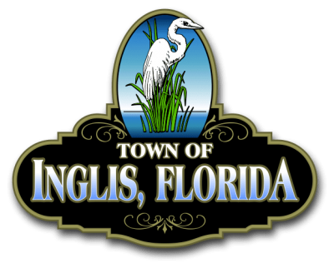 TOWN OF INGLIS
SPECIAL COMMISSION MEETING
SEPTEMBER 17, 2025
Time: 6:30 PM Place: Town Hall
ANY PERSON WHO DESIRES TO APPEAL ANY DECISION MADE BY THE TOWN COMMISSION AT THIS MEETING WILL NEED TO ENSURE THAT A VERBATIM RECORD OF THE PROCEEDINGS IS MADE (SECTION 286.0101.FL STATUTES).

ALL PERSONS DESIRING TO ADDRESS THE TOWN COMMISSION WILL BE ASKED TO LIMIT THEIR COMMENTS TO THE SPECIFIC SUBJECT BEING DISCUSSED AND WILL BE HELD TO ONE (1), THREE (3) MINUTE TIME PERIOD PER AGENDA ITEM.

Prayer
Pledge

ROLL CALL:
MAYOR YOUNG COMMISSIONER AHERN
COMMISSIONER BRODHEAD COMMISSIONER LYNAUGH
COMMISSIONER PARNELL COMMISSIONER REARDON
ATTORNEY FUGATE

Special Agenda
Mayor Young has called this Special Emergency Meeting for the following:

- To approve and vote on Emergency Hiring of Sheryl Pirzer for the Land use/Code Enforcement Officer.
- To approve and vote on Emergency Hiring of Animal Control Officer, Brianna Pirzer.

