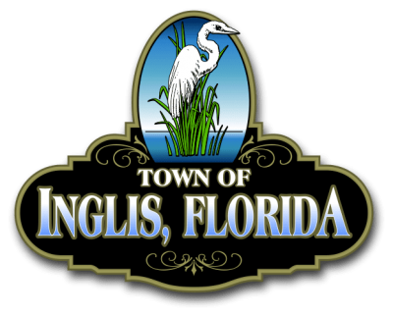 TOWN OF INGLIS
WORKSHOP
JUNE 30, 2025
Time: 6:00 PM Place: Town Hall
ANY PERSON WHO DESIRES TO APPEAL ANY DECISION MADE BY THE TOWN COMMISSION AT THIS MEETING WILL NEED TO ENSURE THAT A VERBATIM RECORD OF THE PROCEEDINGS IS MADE (SECTION 286.0101.FL STATUTES).

ALL PERSONS DESIRING TO ADDRESS THE TOWN COMMISSION WILL BE ASKED TO LIMIT THEIR COMMENTS TO THE SPECIFIC SUBJECT BEING DISCUSSED AND WILL BE HELD TO ONE (1), THREE (3) MINUTE TIME PERIOD PER AGENDA ITEM.

Prayer
Pledge

ROLL CALL:
MAYOR YOUNG
COMMISSIONER BRODHEAD COMMISSIONER LYNAUGH COMMISSIONER PARNELL COMMISSIONER REARDON
COMMISSIONER AHERN ATTORNEY FUGATE

Agenda

- REVIEW RFP BIDS

